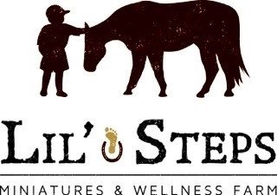
Contact Person: Lucy Fouasse
Address: Box 121, St. Malo, Manitoba, R0A 1T0
Email: lilstepsfarm@gmail.com
Phone: #204-298-7142
Website: lilstepswellnessfarm.net

LIL’ STEPS CAMP REGISTRATION
CHILD’S NAME: _________________________________________________________
ADDRESS: _______________________________________________________________
CITY: ___________________PROVINCE:_______ POSTAL CODE: ______________
AGE: __________
PARENT’S/GUARDIAN’S NAME: __________________________________________

EMAIL: ______________________________HOME PHONE: _____________________

CELL PHONE: ______________________

EMERGENCY CONTACT: __________________RELATIONSHIP: ______________

PHONE NUMBER: ________________ALTERNATE: __________________________

MEDICATIONS? __________________________________________________________
ALLERGIES/FOOD ALLERGIES? __________________________________________
INDICATE THE FOLLOWING CAMP AND DATE(S) YOU ARE REGISTERING FOR:
_____________________________________________________________________________
**CAMP BEGINS AT 9:00 AM & ENDS AT 4:00 PM. PLEASE ENSURE YOUR CHILD HAS PROPER FOOT GEAR (CLOSED TOE), HAT, BAGGED LUNCH, SUNSCREEN AND WATER BOTTLE. **
COST: Two Day Camps - $115.50 includes GST
Three Day Camps - $173.25 includes GST
Five Day Camps - $288.75 includes GST CIRCLE ONE: ____ CASH _____ CHECK
DEPOSIT OF $50.00 MUST BE MADE UPON COMPLETION OF REGISTRATION TO HOLD YOUR CHILD’S SPOT

